**Using T3000 CrossPlatform**

* Open T3000 Executable
* Load BTUMeterRev22.prg
* Open PROGRAMS view.
* Edit any program
* Copy and paste code (with line numbers included)
* Edit and change lines of code.
* Parser is active.

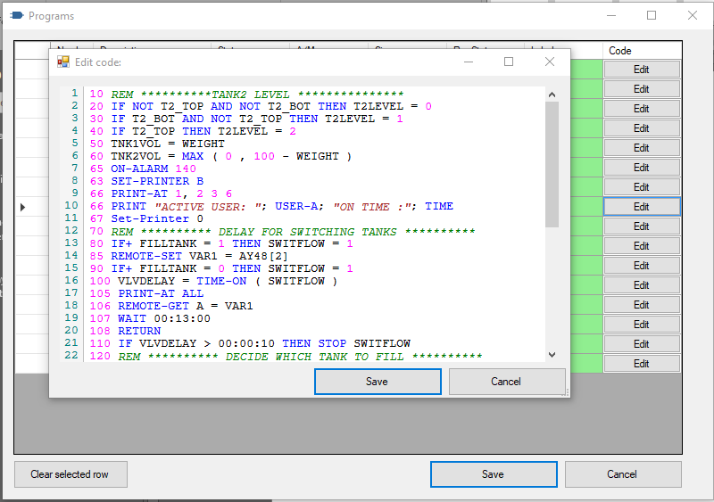

**Using Irony Grammar Explorer (Expert mode, need to know about grammars LR to understand all outputs)**

* Open Irony.GrammarExplorer.exe
* Push Grammars ellipsis button (Only required for the first time) then select “Add Grammar”
* 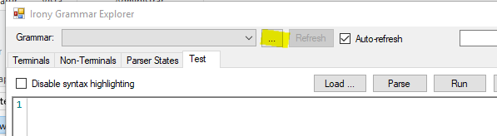
* Locate and select T3000Grammar.dll from Windows Release Files (T3000 Grammar has 4 conflicts, ignore them as they don´t affect parsing)
* Click on button “Load..” and choose a test file (Control Code), suggested (t3000\PRGReaderLibrary.Tests\TestFiles\ProgramCodes\BTUMeter6.txt)
* Parser is active. You can enable Parse Trace check, and click button PARSE to see Parse Tree (on the right) and Parse trace (bottom).

